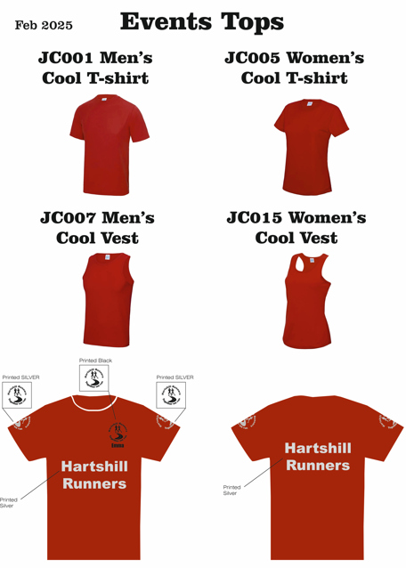
JC001 Men’s T-SHIRT FIRE RED (EVENTS T-SHIRT) £30.00
XS 35"/37" S 37"/39" M 39"/41" L 41"/43" XL 43"/45" 2XL 45"/48" 3XL

JC005 Woman’s T -SHIRT FIRE RED (EVENTS T- SHIRT) £30.00
XS 8 S 10 M 12 L 14 XL 16 2XL 18 3XL 20 4XL 22

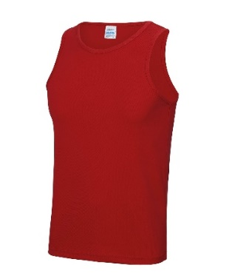
JC007 Men’s Events FIRE RED £24.50
Size = XS 35/36" S 37"/39" M 39"/41" L 41"/43" XL 43"/45" 2XL 45"/48"
JC015 Woman’s Events FIRE RED VEST £24.50
Size = XS 8 S 10 M 12 L 14 XL 16

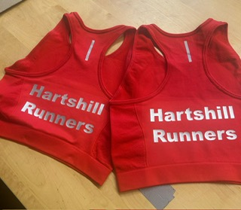
New Events Crop top
Ladies £20.00
SIZE 6,8,10,12,14,16,

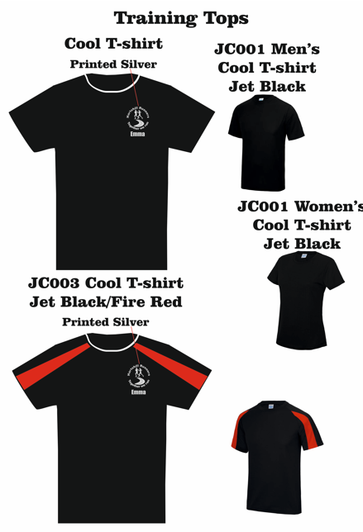
JC003 Unisex BLACK/ RED or RED/BLACK Contrast Cool T-shirt £18.20

Size = XS 35/36" S 37"/39" M 39"/41" L 41"/43" XL 43"/45" 2XL 45"/48"

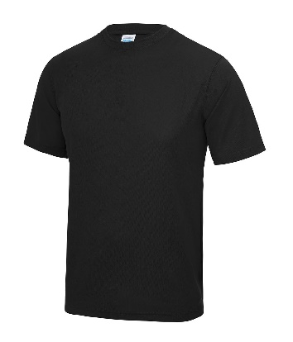
JC001 MEN’S BLACK COOL T SHIRT £16.80
SIZE = XS 35"/37" S 37"/39" M 39"/41" L 41"/43" XL 43"/45" 2XL 45"/48" 3XL 48"/50" 4XL 51"/53" 5XL 54/56"

JC005 WOMENS COOL BLACK T SHIRT £16.80
SIZE = XS 8 S 10 M 12 L 14 XL 16 2XL 18 3XL 20 4XL 22

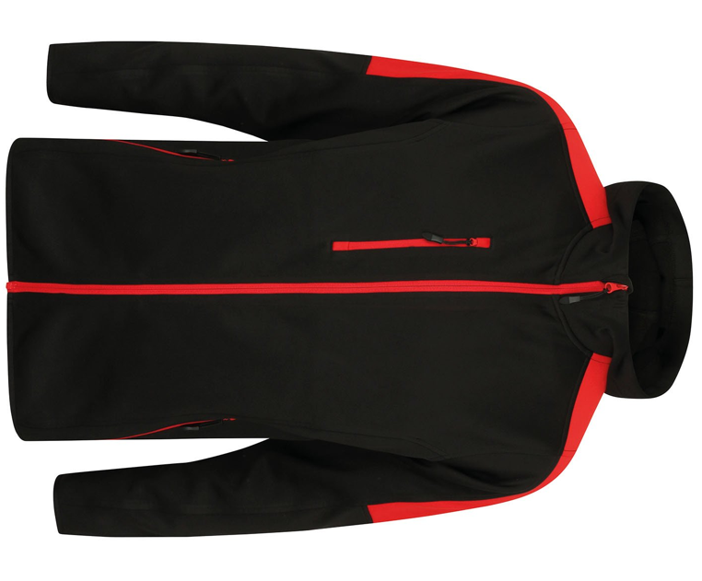
LV622 Unisex £53.60
Size = XS 34/36" S 36/38" M 38/40"

L 42" XL 44/46" 2XL 48"

JH050 Unisex FULL ZIP HOOD FIRE RED £40.00

S 36" M 40" L 44" XL 48" 2XL 52"

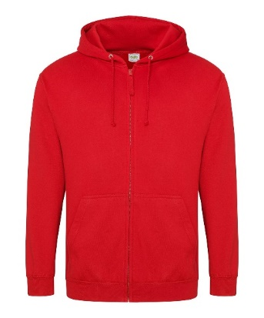

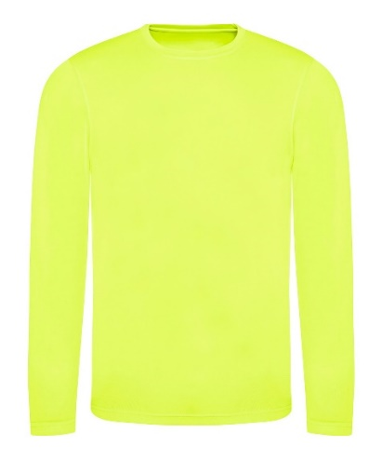
JC002 MEN'S L/SLEEVE T-SHIRT YEL £21.80

S 37"/39" M 39"/41" L 41"/43" XL 43"/45" 2XL 45"/48"

JC012 LADIES L/SLEEVE T-SHIRT YELLOW £21.80
XS 8 S 10 M 12 L 14 XL 16

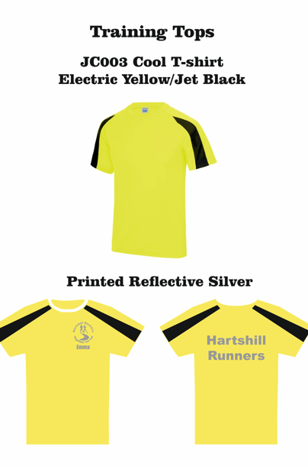
JC003 UNISEX CONTRAST COOL T-SHIRT YELLOW/BLACK
£21.00
Size = XS 35/36" S 37"/39" M 39"/41" L 41"/43" XL 43"/45" 2XL 45"/48

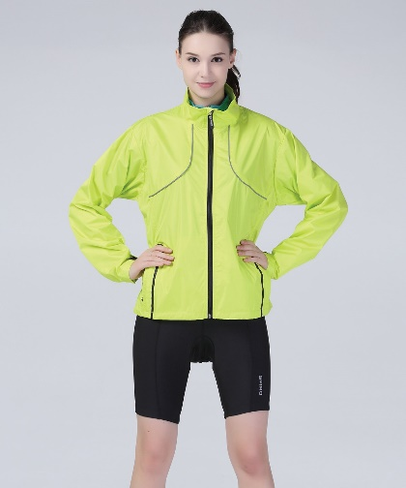
S185X Track Jacket in Neon Lime £52.00

